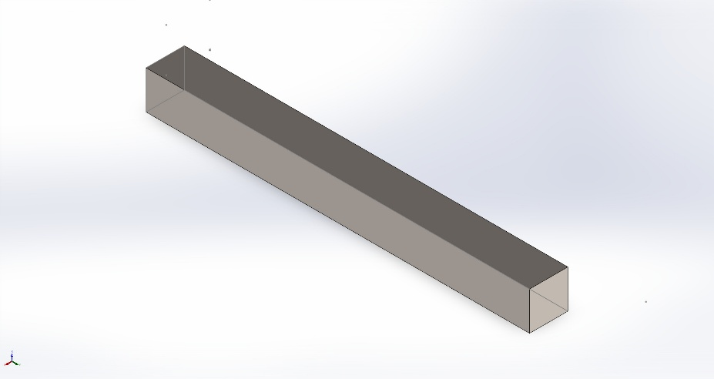 | Simulation of OneBeam  Date: Tuesday, February 24, 2026  Designer: Solidworks  Study name: Static 1  Analysis type: Static  Table of Contents  Description 1  Assumptions 2  Model Information 2  Study Properties 3  Units 3  Material Properties 4  Loads and Fixtures 4  Connector Definitions 5  Interaction Information 5  Mesh information 5  Sensor Details 5  Resultant Forces 6  Beams 6  Study Results 6  Conclusion 6

Description
No Data

Assumptions

Model Information

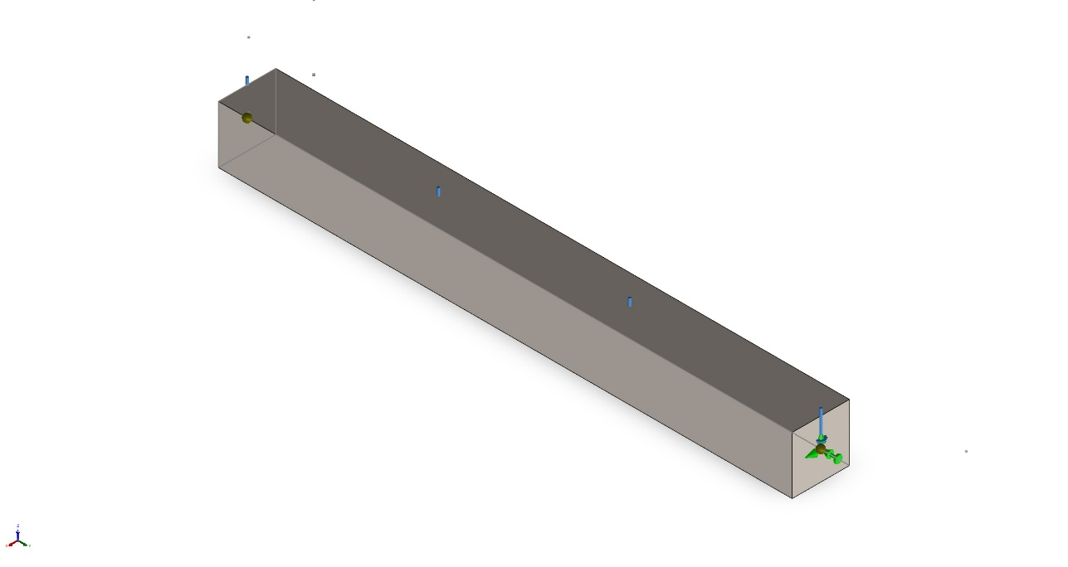
Model name: OneBeam
Current Configuration: Default<As Machined>
Beam Bodies:
Document Name and Reference | Formulation | Properties | Document Path/Date Modified
SolidBody 1(Building 3IN(1))  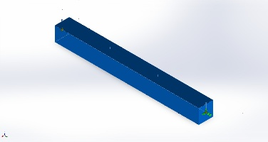 | Beam – Uniform C/S | Section Standard-Custom Profiles/Building/3in  Section Area: 1m^2  Length:10,000mm  Volume:10m^3  Mass Density:7,700kg/m^3  Mass:77,000kg  Weight:754,600N | C:\Users\noaht\School\Spring 2026\FEA\OneBeam.SLDPRT  Feb 24 16:14:39 2026

Study Properties
Study name | Static 1
Analysis type | Static
Mesh type | Beam Mesh
Solver type | Automatic
Inplane Effect: | Off
Soft Spring: | Off
Inertial Relief: | Off
Incompatible bonding options | Automatic
Contact penalty stiffness scale factor | 1
Large displacement | Off
Compute free body forces | On
Result folder | SOLIDWORKS document (C:\Users\noaht\School\Spring 2026\FEA)

Units
Unit system: | SI (MKS)
Length/Displacement | mm
Temperature | Kelvin
Angular velocity | Rad/sec
Pressure/Stress | N/m^2

Material Properties
Model Reference | Properties | Components
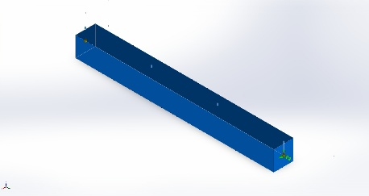 | Name: Alloy Steel  Model type: Linear Elastic Isotropic  Default failure criterion: Unknown  Yield strength: 6.20422e+08 N/m^2  Tensile strength: 7.23826e+08 N/m^2  Elastic modulus: 2.1e+11 N/m^2  Poisson's ratio: 0.28  Mass density: 7,700 kg/m^3  Shear modulus: 7.9e+10 N/m^2  Thermal expansion coefficient: 1.3e-05 /Kelvin | SolidBody 1(Building 3IN(1))(Part1)
Curve Data:N/A

Loads and Fixtures
Fixture name | Fixture Image | Fixture Details
Reference Geometry-2 | 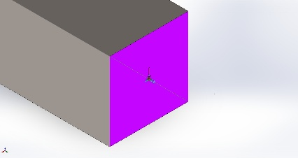 | Entities: 1 Joint(s)  Reference: Face< 1 >  Type: Use reference geometry  Translation: 0, 0, 0  Rotation: ---, ---, 0  Units: mm, rad
Reference Geometry-1 | 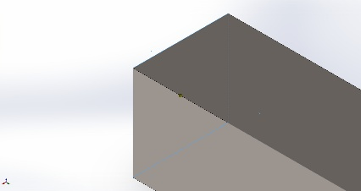 | Entities: 1 Joint(s)  Reference: Face< 1 >  Type: Use reference geometry  Translation: 0, 0, ---  Rotation: ---, 0, ---  Units: mm, rad

Load name | Load Image | Load Details
Force-1 | 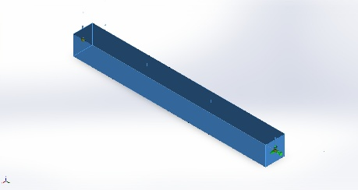 | Entities: 1 Beam (s)  Reference: Face< 1 >  Type: Apply force  Values: ---, ---, 50 N/m  Moments: ---, ---, --- N·m/m

Connector Definitions
No Data

Interaction Information
No Data

Mesh information
Mesh type | Beam Mesh

Mesh information - Details
Total Nodes | 48
Total Elements | 46
Time to complete mesh(hh;mm;ss): | 00:00:00
Computer name: | NOAHSLAPTOP

Sensor Details
No Data

Resultant Forces
No Data
No Data

Beams
No Data

Study Results
No Data

Conclusion

